Silvia Chauhan

Group I

04/12/2020

1. DFD Diagram:

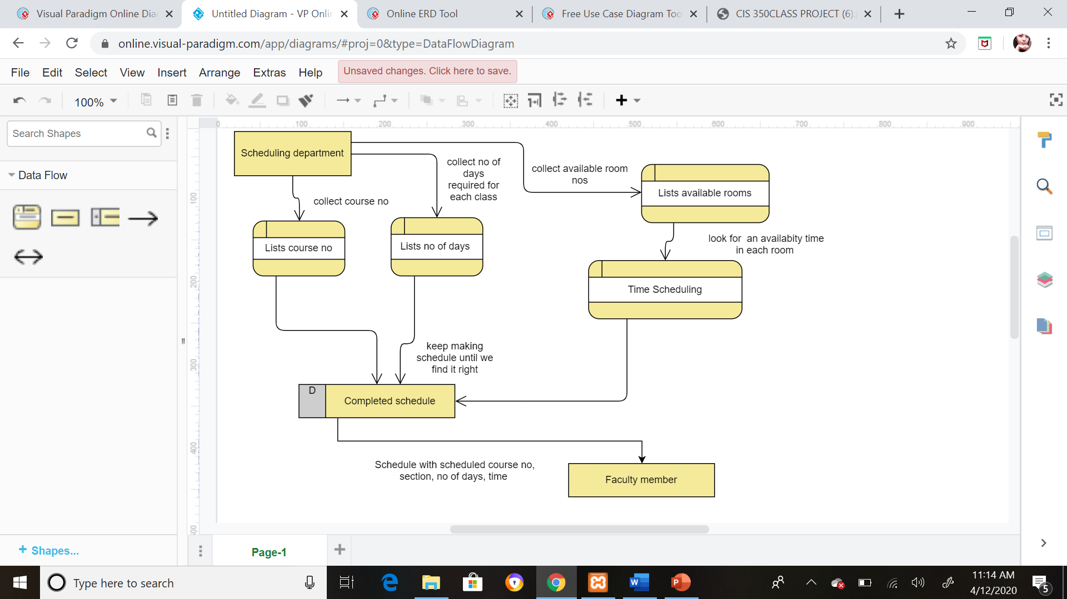

1. Sample of database design(ERD):

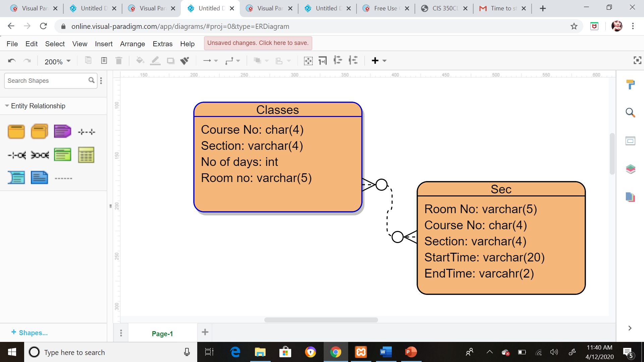

1. User Diagram design(sample):

